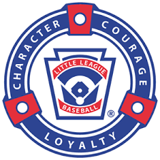
MCLL UNIFORM ORDER FORM
TEAM NAME/ COLOR: ______________________________
MANAGER NAME/CONTACT INFO: _________________________
PLAYER NAME | SHIRT SIZE | NUMBER | HAT SIZE | SOCK SIZE
COACHES/MANAGER NAMES | SHIRT SIZE | HAT SIZE
SEND BACK TO MCLLWV@HOTMAIL.COM OR EQUIPMENT/
UNIFORM COORDINATOR Nicole Shover (304-676-7095) BY FEBRUARY 28, 2024.

